Configure Site-to-Site Wireless Link

**Components:** Routers, Switch, PC

**Theory:** A site-to-site VPN connects users in different locations within an entire network. Through this network, the users can exchange data from their own locations while that information is encrypted and secured through the VPN. Users working in separate offices can still be connected to one another and all of their internal resources. This keeps all users connected even when they are working remotely while securing the information exchanged between them.

**Cisco Packet tracer Setup:**

**Step 1:** Connect all devices and assign IP addresses as shown below

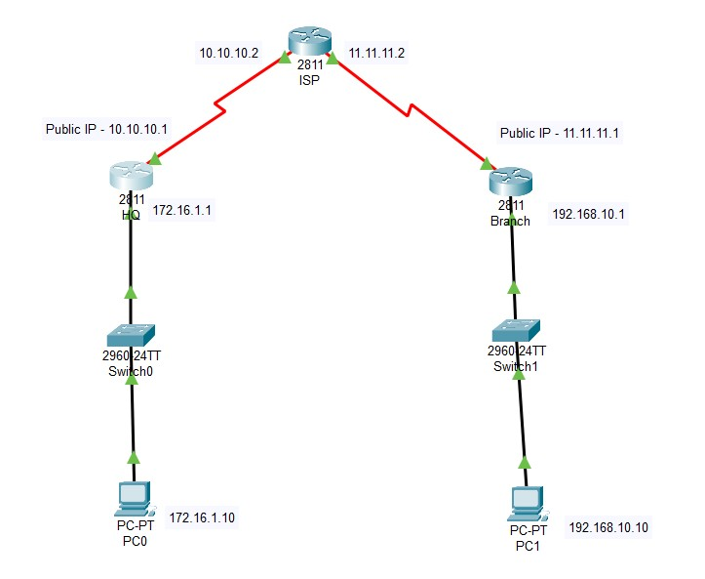

**Step 2:** Set IP route as shown below in the ISP router

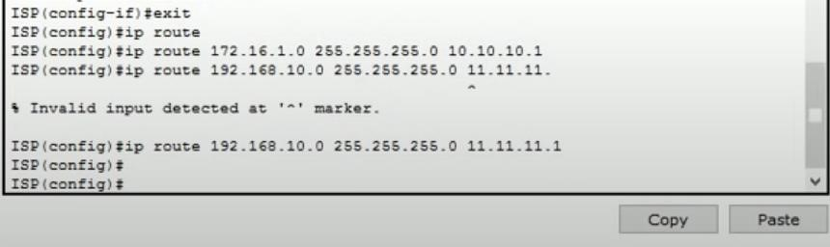

**Step 3:** Try pinging from PC0 or PC1 to check the connection.

In Desktop, Command prompt

C:\> ping 192.168.10.10

**Step 4:** Configure iskamp policy and define IPsec transform set by entering the commands given below in the HQ router

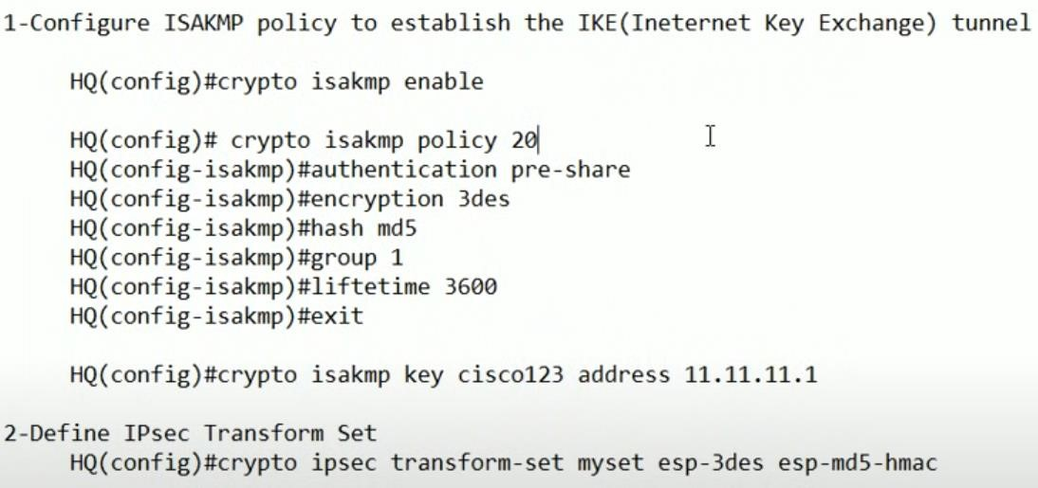

**Step 5:** Create access list and crypto map in the HQ router CLI

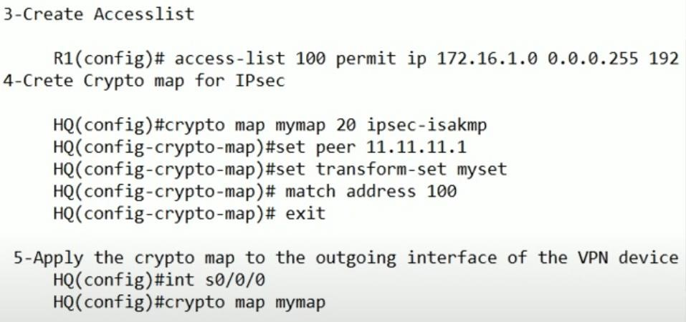

**Step 6:** Perform the above 2 steps for the Branch router and change the IP addresses accordingly **Output:**

Verify the created isakmp policies with the following command

